Queue Monitoring For Windchill GPDM

Table of Contents
General: 3
CAD Worker Queues 3
Office Worker Queues 3
WfUserWorkQueue…………………………………………………………………………......4
WfPropagationQueue……………………………………………………………………………5
Handling Severe Entries in IndexQueue1 and IndexQueue2 5
Generic Queue Monitoring………………………………………………………………………5
List of Other Queues to Monitor……………………………………………………………………..5
Action Required………………………………………………………………………………..5

​
This document provides guidelines for monitoring and resolving issues in Windchill queues to ensure smooth publishing and workflow execution.

General:
Publisher queue alerts must always be treated with high priority, as delays or stoppages directly impact publishing performance.
- CAD Worker Queues (Example: PublisherQueueCADQH PublisherQueueCADQL, PublisherQueueCADQM, PublisherQueueCADQ1)
Email Alert on Queue Problems: There are 19 queue entries waiting to be executed in queue PublisherQueueCADQH
Action: The steps outlined below apply to all CAD worker queues.
- If PublisherQueueCADQH is found stopped, verify its current status in the Queue Management page.
- If confirmed as stopped, start the queue immediately.
- Monitor the queue after starting to ensure entries are processed successfully.
- Review the logs to determine the reason for the stoppage (for example, server restart, deadlock, or resource unavailability).
- Office Worker Queues (Example: PublisherQueueOFFQ1, PublisherQueueOFFQM, PublisherQueueOFFQH, PublisherQueueOFFQL)
Email Alerts on Queue Problems:
Alert 1: Queue entry 128669927 in PublisherQueueOFFQ1H has exceeded its execution time.
Alert 2: There are 438 queue entries waiting to be executed in PublisherQueueOFFQ1.
Action: The steps outlined below apply to all Office worker queues.
Follow the steps below for investigation and resolution:
- Confirm whether the queue is running or stopped.
- If stopped, restart the queue and review the logs to understand the reason.
- Monitor the queue for approximately 30 minutes.
- Identify if any entries remain in the Executing State for an extended time.
- Check out the WVS Job Monitor for any executing jobs related to this entry.
- If such entries are found, analyze the queue entries to identify the cause.
- Verify which Publisher (Office) is currently processing the job.
- Ensure there are no prompts or system errors interrupting the process.
- If no issues are visible, confirm whether the document has exceeded the configured timeout value.
If publishing jobs remain in Executing state even after analysis: Connect to the AWS server and sql plus.
-- Identify executing publish jobs
SELECT entryNumber, codec5, ida2a2 FROM queueentry WHERE codec5='EXECUTING' AND targetClass='com.ptc.wvs.server.publish.PublishJob';
-- Manually update to completed if confirmed safe
UPDATE queueentry SET codec5='COMPLETED' WHERE ida2a2= '<ida2a2 from above>' AND codec5='EXECUTING';
Or
UPDATE QUEUEENTRY SET codec5='NONEVENTFAILED' where ida2a2=' <ida2a2 from above> ' AND codec5='EXECUTING';
If Jobs Remain Stuck even after marking it Completed/Failed:
- Restart the BackgroundWVS process.
- Inform Ravi before performing this restart.
- There is no need to create an admin activity for this action.

Steps for restarting the BackgroundWVS process:-
- Connect to the AWS server
- Open Session manager and start the session with master node.
- Do root log in with the command ‘sudo su -’.
- Use ‘checkps’ command to check the processes.
- Look for ‘BackgroundWVS’ process IDs.
- Kill the child process ID using command ‘kill -9 <Id>’
- To confirm that the new process has started, run ‘checkps’ command again.
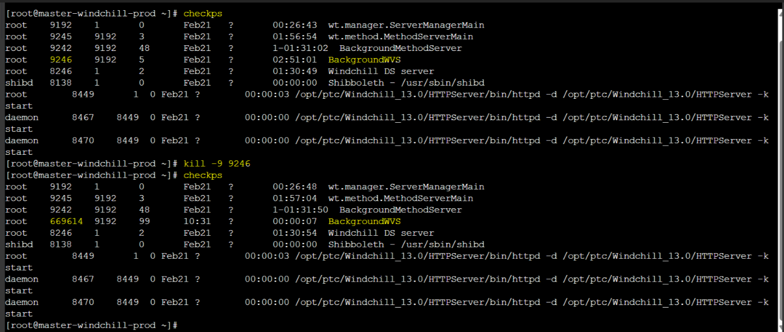
- WfUserWorkQueue :
Email Alert on Queue Problems:
The execution time of queue entry 118669928 in WfUserWorkQueue has exceeded the maximum allowable limit.

Action:
- Please monitor the queue for the next 30 minutes to verify that the entry is completed successfully.
- If the entry remains in the Executing state, review the Process Manager to identify where it is stuck.
- Some entries in the Executing state are observed to be stuck at the DeleteTempFile activity, which is currently running. In such cases, it is acceptable to manually complete the DeleteTempFile activity and remove the corresponding queue entries, as this task typically occurs at the end of the workflow.
Note:
Manual intervention should only be performed once it is confirmed that DeleteTempFile is the final activity before the workflow concludes.
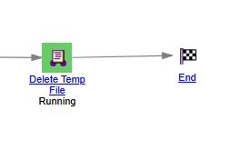
Document stuck at Reassign LC step (with check out error)
When a document is already in the Effective state but gets stuck at the Reassign LC step in the Effective workflow with a checkout error,
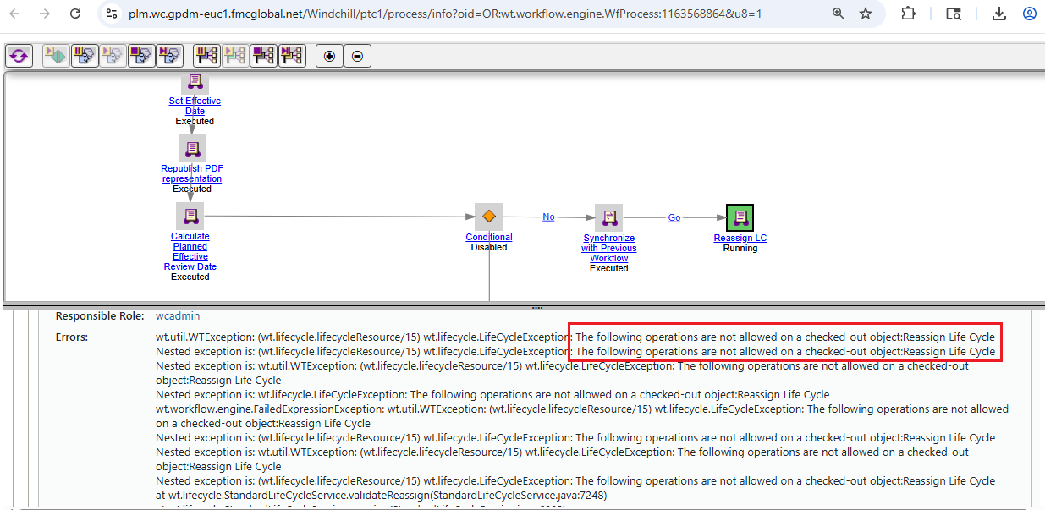
Action:
The resolution is to refresh the corresponding queue entry as below:
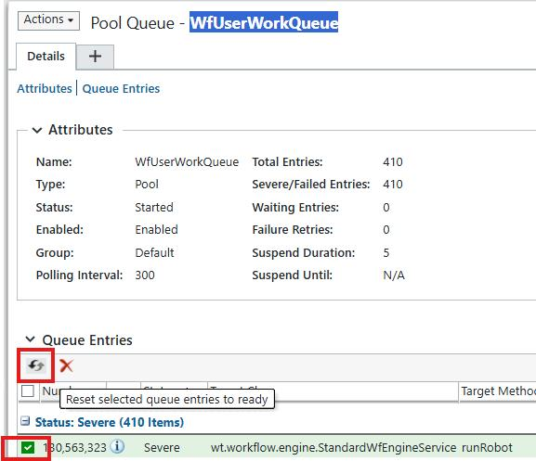

- WfPropagationQueue :
- Check for New Severe Entries
  - The queue currently has 19 older entries. Please monitor any new entries beyond this count.
  - If you notice more than 19 entries, focus on those with the highest job numbers.
- Review Workflow Status
  - Click on the link associated with each entry to inspect its workflow.
  - Check if the workflow is stuck at any point and take appropriate action to clear it.
  - Ensure that any running activity is completed.
- Reset Completed Workflows
  - If the workflow has already been completed, you may reset the queue entry.
  - This will remove the entry from the queue.
Handling Severe Entries in IndexQueue1 and IndexQueue2:
- Identify Severe Entries
  - Check both IndexQueue1 and IndexQueue2 for any entries marked as "severe."
- Attempt to Reset
  - Try resetting the severe entries and monitor whether they clear from the queue.
- Delete if Necessary
  - If the entries do not go away after the reset, you may proceed to delete them.
  - This is safe to do, as the re-indexing process will automatically occur during the next cycle.
Generic Queue Monitoring:
- List of Other Queues to Monitor:
  - CtmdRecomputeMembershipQueue
  - NotificationQueue
  - WfScheduleQueue
  - commonScheduleQueue
  - EMailQueue
  - FMCExtractPDFProcessingQueue
  - FMCDocumentProcessingQueue
- Action Required
  - We need to review the queue, restart it if stopped, verify the logs, and inform the technical team when any issues are identified.

Issues: Terminate CR/CN still shows Planning State instead of Cancelled State

If Terminate CR/CN was initiated but the state was not updated to Cancelled due to an exception and a subsequent state change has already taken place; verify if there are any workflow iteration discrepancies.
Steps to perform:
- Set the object state to Cancelled, as it was expected to be in the Cancelled state.
- Reassign the lifecycle:
  - Select “Use latest iteration of current lifecycle”
  - Ensure “Preserve current state” is selected
- If a queue entry exists, delete the entry instead of refreshing it

